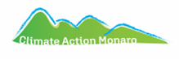
2026 CLIMATE ACTION MONARO ART COMPETITION coc
RAGLAN GALLERY COOMA
29th April to 14th June 2026
Official Opening 2nd MAY 3PM
THEME: EXTREME WEATHER
COMPETITION ENTRY FORM
ENTRY FORMS: To the Raglan Gallery directly or email to info@raglangallerycooma.com
by Thursday April 16th 2026. $15 per entry $5 student entry (2 entry limit)
DELIVERY OF ARTWORK : by Thursday 23rd April to the Raglan Gallery. Pull down Sun 14th June
PRIZES : ADULT 1st $1500 2nd $1000 3rd $500
YOUTH : Sec: 1st $200 2nd $150 3rd $100 Primary: $150 2nd $100 3rd $50
Accepted art styles: Painting, Drawing & Photography / Size Limit - 1 x metre on longest side [inc frame]
Artist’s Name………………………………………………………… Applying for: Open / Secondary / Primary
Address…………………………………………………………………………. Postcode………………
Phone…………………………… Email………………………………………………………………………

Artist Payment Details for Direct Deposit sales. NAME: | BSB : | ACC :
I understand and acknowledge the terms and conditions [on page 2] of entering the CAM Art Award
Signed ……………..………………………………………………………………………………. Date …………………………….…
ARTWORK 1  Title:………………………………………………………  Medium:…………………………… Editioned…………  Sale Price: $................ [inc. commission 25%/30%] | ARTWORK 2  Title:………………………………………………………  Medium:…………………………… Editioned…………  Sale Price: $................ [inc. commission 25%/30%]

ENTRY FEE TOTAL $................... ($15 / $5) per work - 2 entry limit) PAYMENT METHOD :…………………
- Entry fee payment : Cash/ or payment at Raglan Gallery, 9- 11 Lambie St, Cooma OR
Direct deposit to: Climate Action Monaro Inc BSB 633 000 : Account: 203 701 768 - reference CAM art and YOUR NAME .

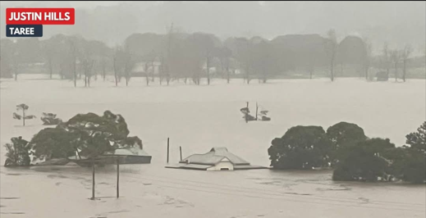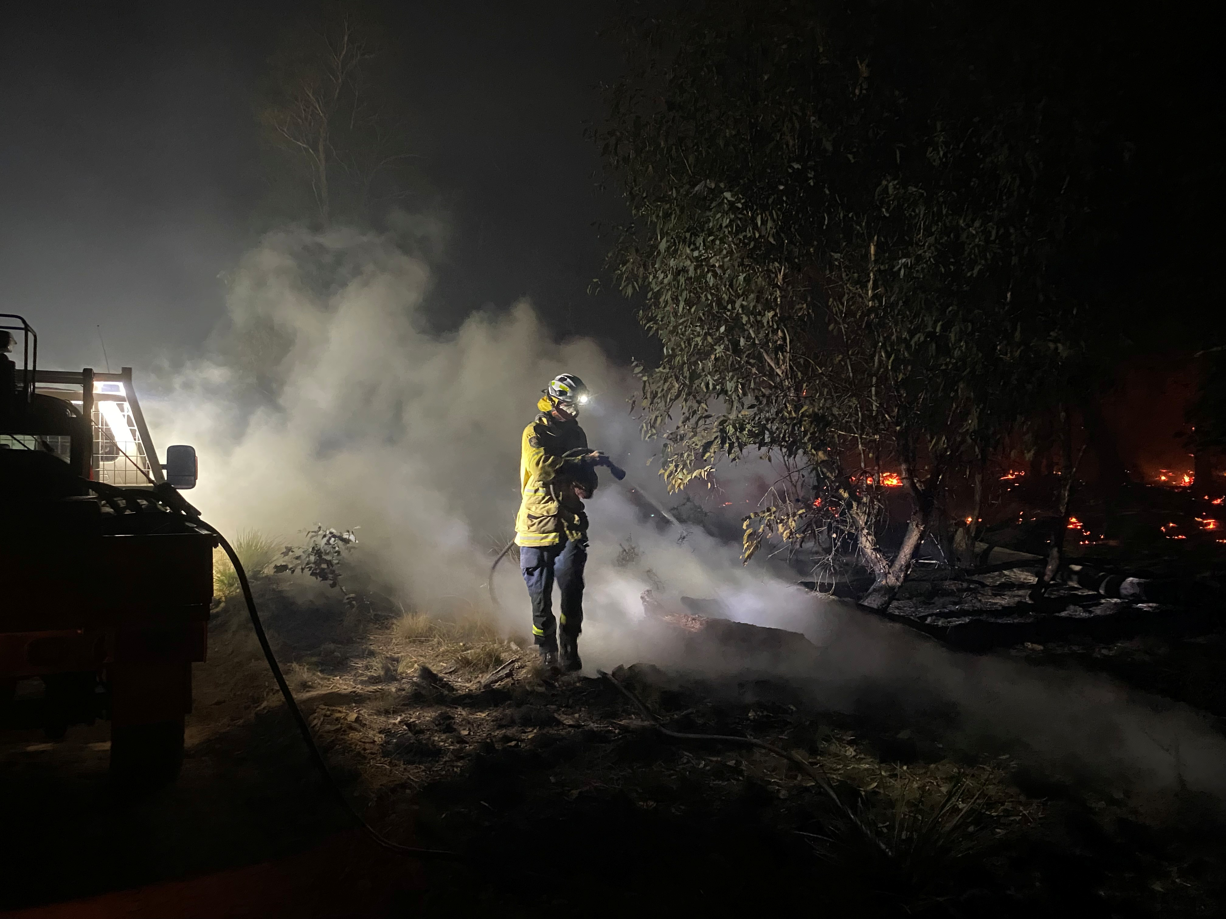
Photo Justin Hills photo Danny Henderson

Terms and Conditions of entering the CAM Art Award

PRIZES : Adults : 1st - $1500 2nd - $1000 3rd - $500
Youth Sec : 1st - $200 2nd - $150 3rd – $100 Primary : 1st - $150 2nd - $100 3rd – $50
People’s Choice Award -$500
Conditions of Entry

~ Entry forms must be delivered and payment accepted by the due date, otherwise you cannot enter
~ Each individual artist MUST sign the entry form -and provide receipt of payment.
~ 2 entry limit per person
~ The artwork must feature or reflect the theme “Extreme Weather”
~ There is no time limit when the artwork was created
~ 2D art forms accepted only - ie, painting, drawing, pastels, photographs, lino cuts prints. No SCULPTURES
~ Maximum size of each entry, including the frame, is not to exceed 100cm [1 metre] on the longest side.
~ All image content must be the copyright of the artists. Artist must have any permissions required.
CAM and Raglan Gallery take no responsibility for breach of copyright
~ Copyright remains with the artist
~ All artworks to be delivered dry and ready to hang fitted with D-Rings, wire or cord. Otherwise they will not be hung.
~ Artworks must be clearly labelled on the back of the work - Name, title, size, sale price [including commission]
~ Artworks must be collected at the end of the exhibition - unless sold – dates to be confirmed
~ Sale prices must include commission of 30% Non-Raglan members or 25% for Raglan Members and applies to any works presold
~ If you are selling editions please indicate this and how many in the edition
~ Please indicate using N/A if artwork is not for sale
~ By entering you give permission for your artwork to be used in promotion and publicity of the CAM Art Awards
~ CAM and Raglan Gallery reserve the right not to hang any work that does not comply with the criteria
~ Judges decisions are final - no correspondence will be entered into.

~ People’s Choice Award will be announced on the last day of the exhibition. Sunday 14th June 2026
Voting can only be made at the exhibition in the Raglan Gallery.

Please write a 100 word or less description of your artworks:

ARTWORK 1 :…………………………………………………………………………………………………………………
…………………………………………………………………………………………………………………………………..
…………………………………………………………………………………………………………………………………..
ARTWORK 2 : ………………………………………………………………………………………………………………
…………………………………………………………………………………………………………………………………..
…………………………………………………………………………………………………………………………………..

Climate Action Monaro calls on artists to be engaged, through art, with positive and necessary change.

